WORKSHOP — PUNTO 3
Academic Season Preparation Analysis
Academic Database (AD) — Oracle Live SQL

Universidad • 2026

1. Introduction

The academic season is approaching and the university administration requires a comprehensive review of previous academic years. This document presents the analysis of data from the Academic (AD) database, covering academic sessions, course information, department structure, and faculty details.

The administrators specifically requested:
- All data consolidated in a single table (FULL OUTER JOIN)
- Identification of missing information (NULL values)
- Detection of duplicate records
- Identification of faculties/departments that need to be strengthened
- Additional relevant information for the new academic season

2. Data Sources & Tables Used

The following tables from the AD schema were used in the analysis:

Table | Key Columns | Purpose
AD_ACADEMIC_SESSION | SESSION_ID, SESSION_NAME | Academic year periods
AD_COURSE_DETAILS | COURSE_ID, COURSE_NAME, SESSION_ID, DEPARTMENT_ID | Course catalog
AD_DEPARTMENTS | DEPARTMENT_ID, DEPARTMENT_NAME, HOD | Department structure
AD_FACULTY_DETAILS | FACULTY_ID, FIRST_NAME, LAST_NAME, JOB_ID, HIRE_DATE, SALARY | Faculty roster
AD_FACULTY_COURSE_DETAILS | FACULTY_ID, COURSE_ID | Course-Faculty assignments
AD_JOBS | JOB_ID | Job role catalog

3. Consolidated Table — Full Outer Join

The following query consolidates all required information into a single result set using FULL OUTER JOIN to ensure no records are excluded, even if they lack matching entries in related tables.

Query: Full Outer Join Consolidation

The query joins AD_ACADEMIC_SESSION → AD_COURSE_DETAILS → AD_DEPARTMENTS → AD_FACULTY_COURSE_DETAILS → AD_FACULTY_DETAILS using FULL OUTER JOIN at each step, producing 15 records that represent the complete academic picture across all sessions.

Consolidated Results — 15 Records
SESSION | SESSION NAME | DEPARTMENT | HOD | COURSE ID | COURSE NAME | FACULTY
100 | SPRING SESSION | ACCOUNTING | MARK SMITH | 192 | COST ACCOUNTING | Steven King
100 | SPRING SESSION | ACCOUNTING | MARK SMITH | 193 | STRATEGIC TAX... | Steven King
100 | SPRING SESSION | ACCOUNTING | MARK SMITH | 190 | PRINCIPLES OF ACC. | Bruce Ernst
100 | SPRING SESSION | ACCOUNTING | MARK SMITH | 191 | INTRO BUSINESS LAW | David Austin
100 | SPRING SESSION | LITERATURE | ANITA TAYLOR | 189 | COLLEGE READING | Neena Kochhar
200 | FALL SESSION | BIOLOGY | DAVE GOLD | 196 | INTRO PLANT PHYS. | Lex De Haan
200 | FALL SESSION | BIOLOGY | DAVE GOLD | 194 | GENERAL BIOLOGY | Alex Hunold
200 | FALL SESSION | BIOLOGY | DAVE GOLD | 195 | CELL BIOLOGY | Bruce Ernst
200 | FALL SESSION | BIOLOGY | DAVE GOLD | 197 | MARINE BIOLOGY | Daniel Faviet
200 | FALL SESSION | LITERATURE | ANITA TAYLOR | 176 | BUSINESS WRITING | Neena Kochhar
300 | SUMMER SESSION | COMP. SCIENCE | LINDA BROWN | 199 | WEB PROGRAMMING | Valli Pataballa
300 | SUMMER SESSION | COMP. SCIENCE | LINDA BROWN | 198 | SIMULATION & MOD. | Valli Pataballa
300 | SUMMER SESSION | COMP. SCIENCE | LINDA BROWN | 187 | DATA STRUCTURES | Diana Lorentz
300 | SUMMER SESSION | COMP. SCIENCE | LINDA BROWN | 188 | OOAD | Nancy Greenberg
300 | SUMMER SESSION | LITERATURE | ANITA TAYLOR | 175 | AMERICAN LITERATURE | Diana Lorentz

4. Data Quality Analysis

4.1 NULL Values (Missing Information)
The NULL analysis query was executed across all columns of the consolidated view. The result:

Column Checked | NULLs Found | Status
SESSION_NAME | 0 | ✓ Complete
DEPARTMENT_NAME | 0 | ✓ Complete
COURSE_NAME | 0 | ✓ Complete
FACULTY_NAME | 0 | ✓ Complete

Finding: The database contains no NULL values. All records are fully populated across all key fields, indicating strong data integrity.

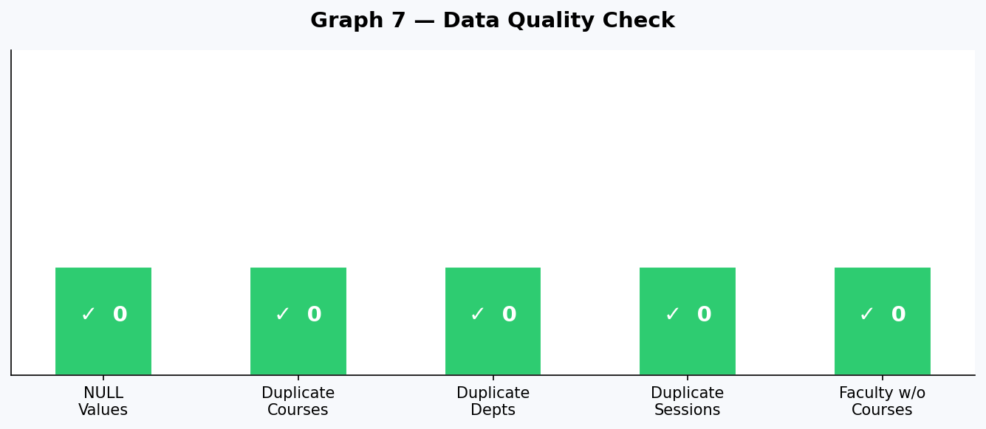

4.2 Duplicate Records
Duplicate detection queries were executed on courses, departments, and sessions:
- Duplicate courses: 0 found
- Duplicate departments: 0 found
- Duplicate sessions: 0 found

Finding: There are no duplicate records in any table. The data is clean and consistent.

5. Academic Analysis — Graphs & Findings

5.1 Courses per Department
The Literature department stands out as having fewer courses (3) compared to the other departments (4 each). This represents the most academically underserved area of the university.

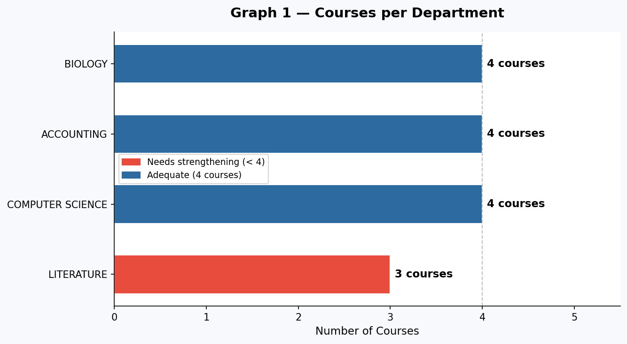

Finding: Literature has 25% fewer courses than the average. This department should be prioritized for course expansion before the new academic season.

5.2 Courses per Academic Session
Each session hosts a balanced number of courses. The Summer Session has the highest unique course count (5), making it the most academically intensive period.

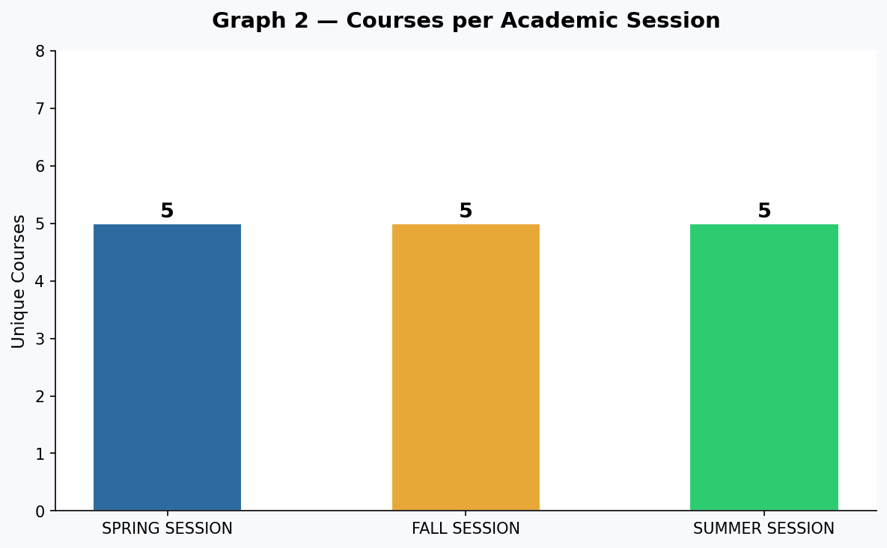

Finding: All three sessions are relatively balanced, with Literature appearing as a cross-session department (present in all 3), but contributing only 1 course per session.

5.3 Teaching Load per Faculty Member
Faculty teaching loads are split between 1 and 2 courses per member. Five faculty members carry only 1 course, representing potential underutilization.

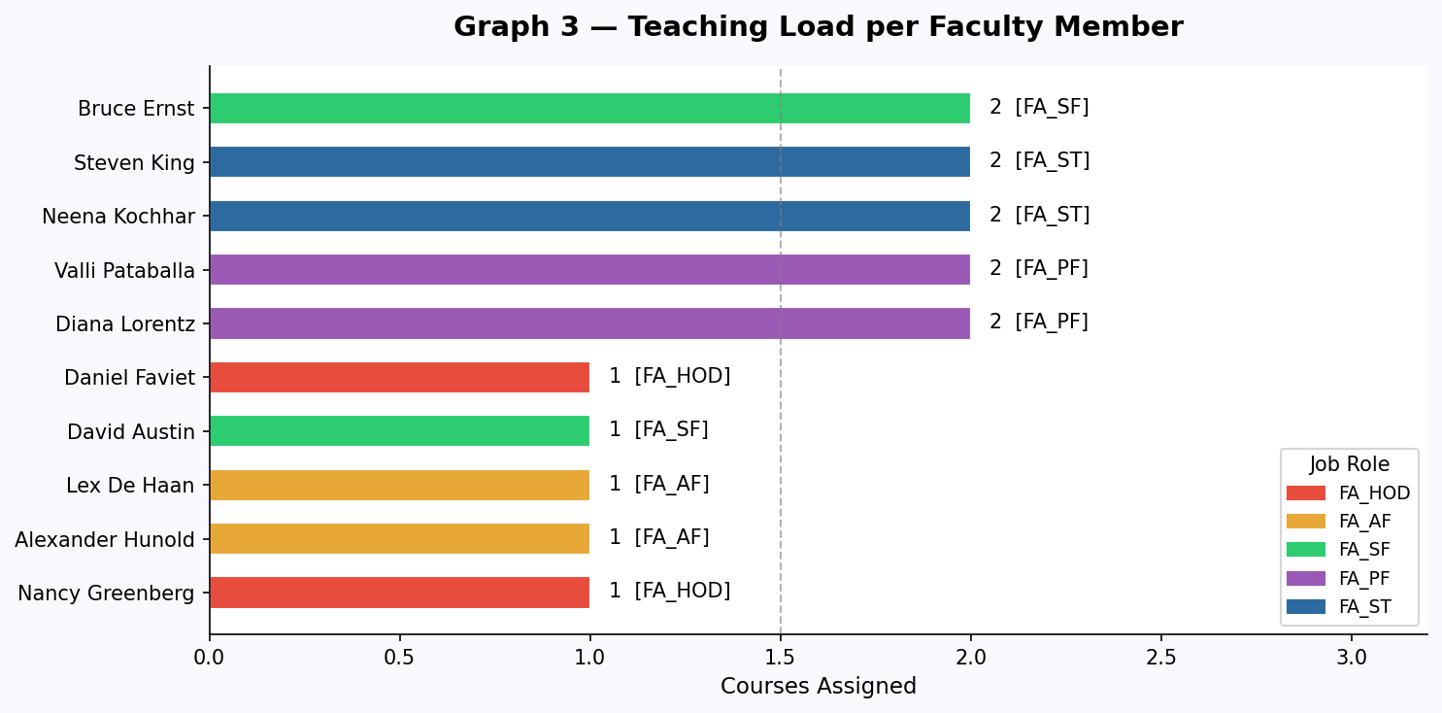

Finding: FA_HOD and FA_AF roles have the lightest teaching loads (1 course each). While FA_HOD is expected (management role), FA_AF faculty could potentially take on additional courses.

5.4 Department Activity per Session
The stacked bar chart shows how departments distribute their courses across the three academic sessions. Biology and Computer Science are concentrated in single sessions, while Literature spans all three.

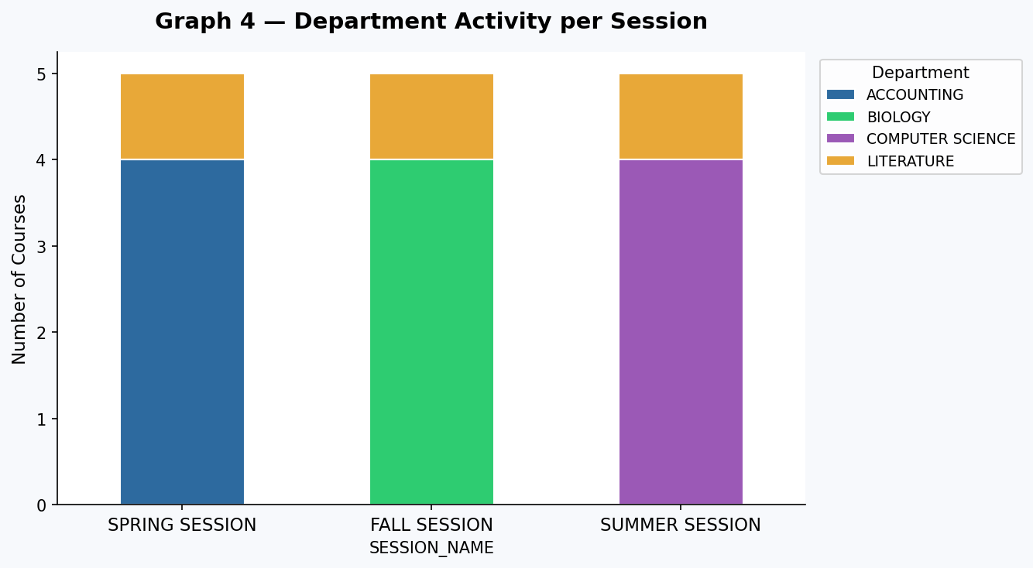

Finding: Single-session concentration of Biology and Computer Science creates an uneven academic load. Redistributing some courses across sessions could improve resource planning.

5.5 Average Salary by Job Role
There is significant salary disparity between roles. FA_HOD (Head of Department) earns substantially more than teaching roles, which is expected for management positions. However, FA_AF and FA_ST roles are notably underpaid relative to their peers.

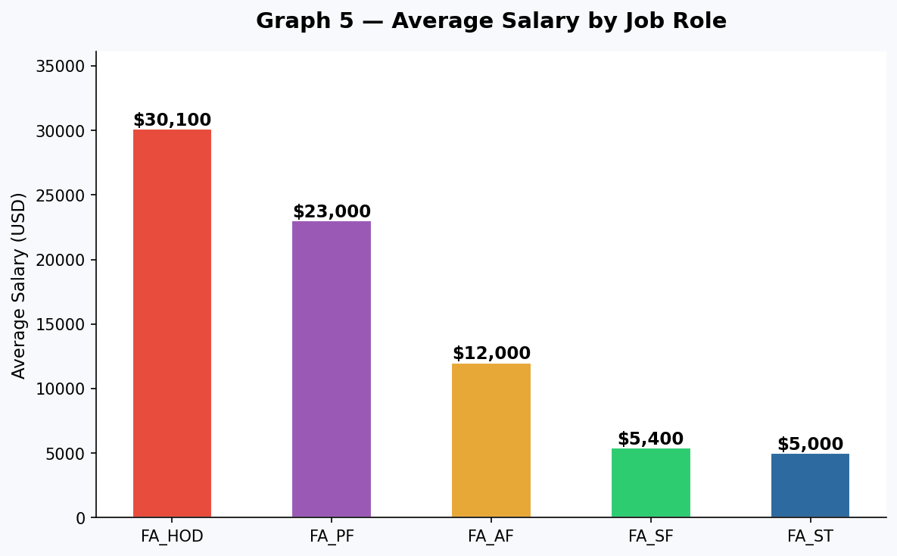

Finding: The salary gap between FA_HOD ($30,100 avg) and FA_AF ($12,000 avg) is significant. A salary review for junior roles (FA_AF, FA_ST) may be needed to retain talent and attract new faculty.

5.6 Faculty Hiring Timeline
All faculty were hired between 2010 and 2015. No new hires have been recorded since 2015, representing a 10+ year gap in faculty recruitment.

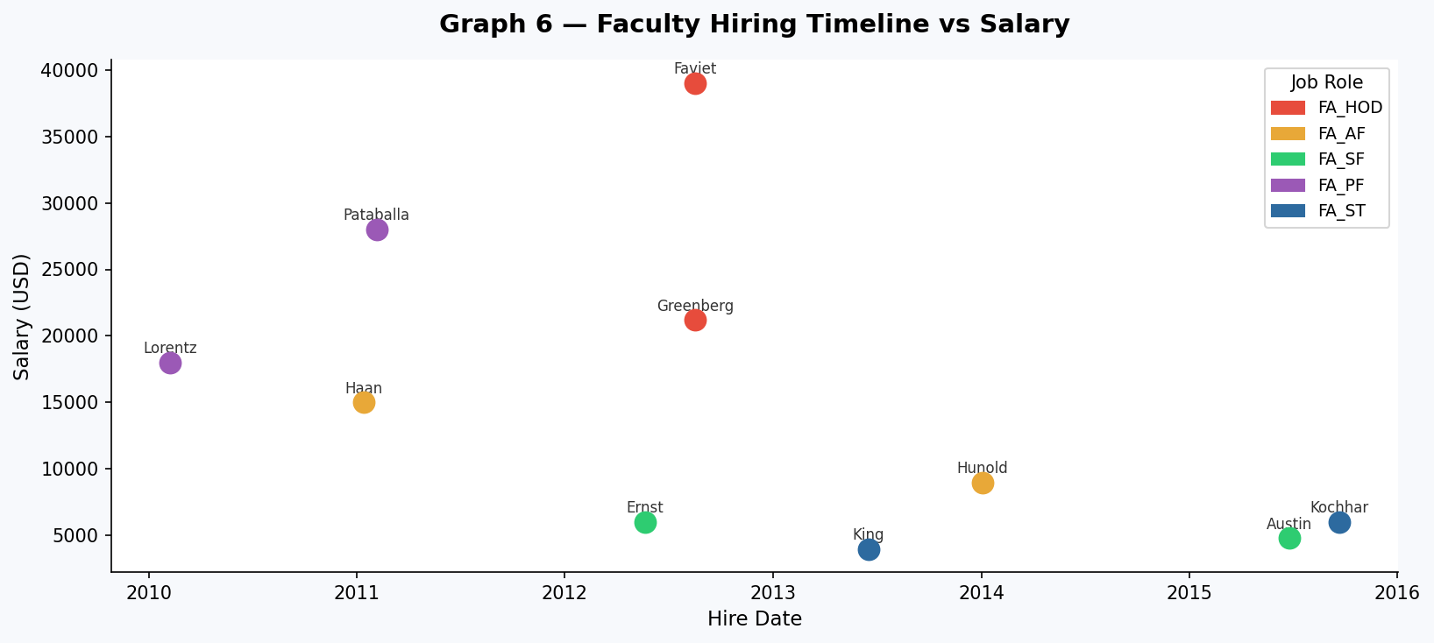

Finding: The 10-year hiring gap is the most critical finding. Without new faculty, the university risks knowledge stagnation, increased workload on existing staff, and inability to offer new courses. This is urgent before the new academic season.

6. Faculties That Need Strengthening

Based on the analysis, the following areas require priority attention:

Department / Role | Current Courses | Issue | Recommendation
LITERATURE (Dept) | 3 courses | Below average | Add 1-2 new courses; hire specialist faculty
FA_AF (Role) | 1 course/faculty | Underloaded | Assign second course to Lex De Haan & Hunold
FA_HOD (Role) | 1 course/faculty | Low teaching load | Evaluate if HOD can take on 1 additional course
ALL (Hiring) | No hires since 2015 | 10-yr gap | Urgent: recruit at least 2-3 new faculty members

7. Proposals for the New Academic Season

Short-term (Before Season Opens)
- Expand Literature department: add at least 1 new course to reach parity with other departments
- Reassign Lex De Haan and Alexander Hunold (FA_AF) to cover an additional course each
- Review David Austin's (FA_SF) capacity to take a second course

Medium-term (During Season)
- Launch a faculty recruitment drive — target at least 2 new hires in FA_AF and Literature
- Redistribute Biology and Computer Science courses across sessions to balance academic load
- Review and adjust salary structure for FA_AF and FA_ST roles to remain competitive

Long-term (Strategic)
- Establish a 3-year faculty succession plan to avoid future hiring gaps
- Create a minimum course-per-department policy (at least 4 courses per department)
- Implement annual data quality audits to maintain the current high standard of data integrity

8. Conclusions

The Academic (AD) database is in excellent condition — zero NULLs and zero duplicates confirm strong data governance. The university is well-organized with clear session structures and department ownership.

However, three critical gaps must be addressed before the new academic season:
- The Literature department is the weakest academically and needs immediate course expansion
- Half of the faculty carry only 1 course, suggesting room for workload rebalancing without new hires
- The 10-year faculty hiring gap is the most urgent strategic risk facing the institution

Addressing these three areas — especially the hiring gap — will position the university to deliver a stronger, more resilient academic season and ensure long-term institutional health.

— End of Analysis Document —

